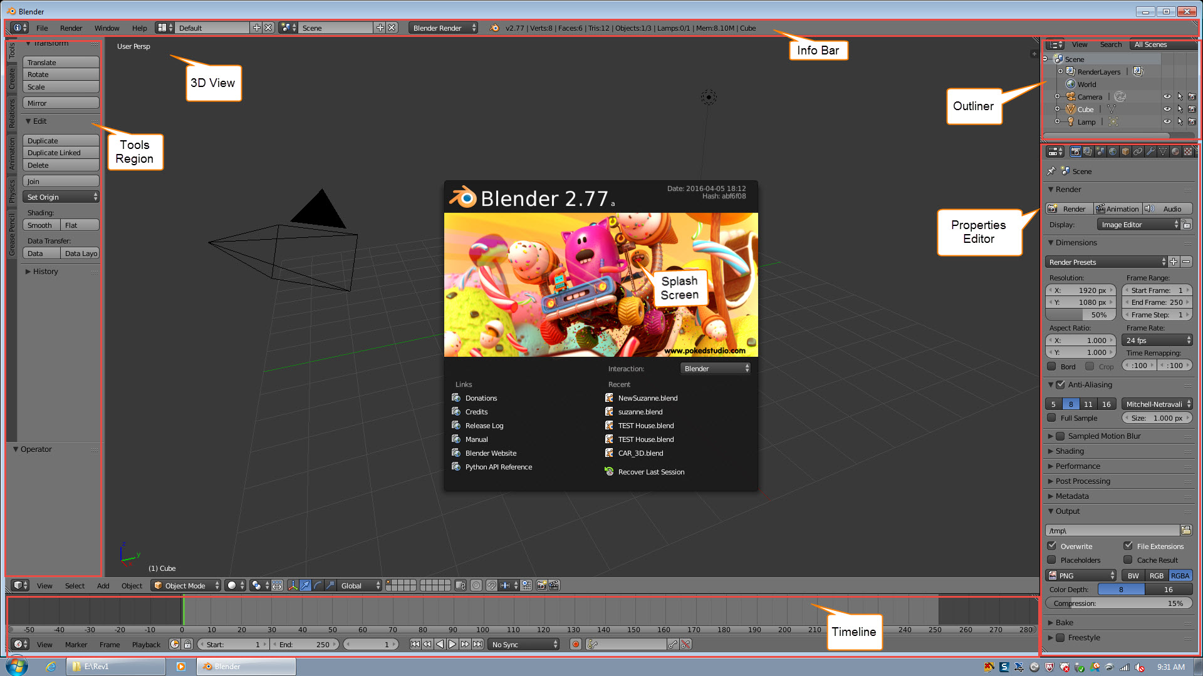

Software Interface: Start Program Describe Blender Interface

**Info Bar** – This is the main menu. Includes Save, Save As, Load, Render and others.

**3D View** – The drawing area where you create designs.

**Tools Region** – Access to common tools

**Tmeline** – Represents time dimension by frames. It has a Start and End Frame.

**Outliner** – Is a representation of the current design scene as a tree structure. It lists the object in the design that you can quickly select.

**Properties** **Editor** – One of the most important features. You will fine options, parameters and modifiers and much more.

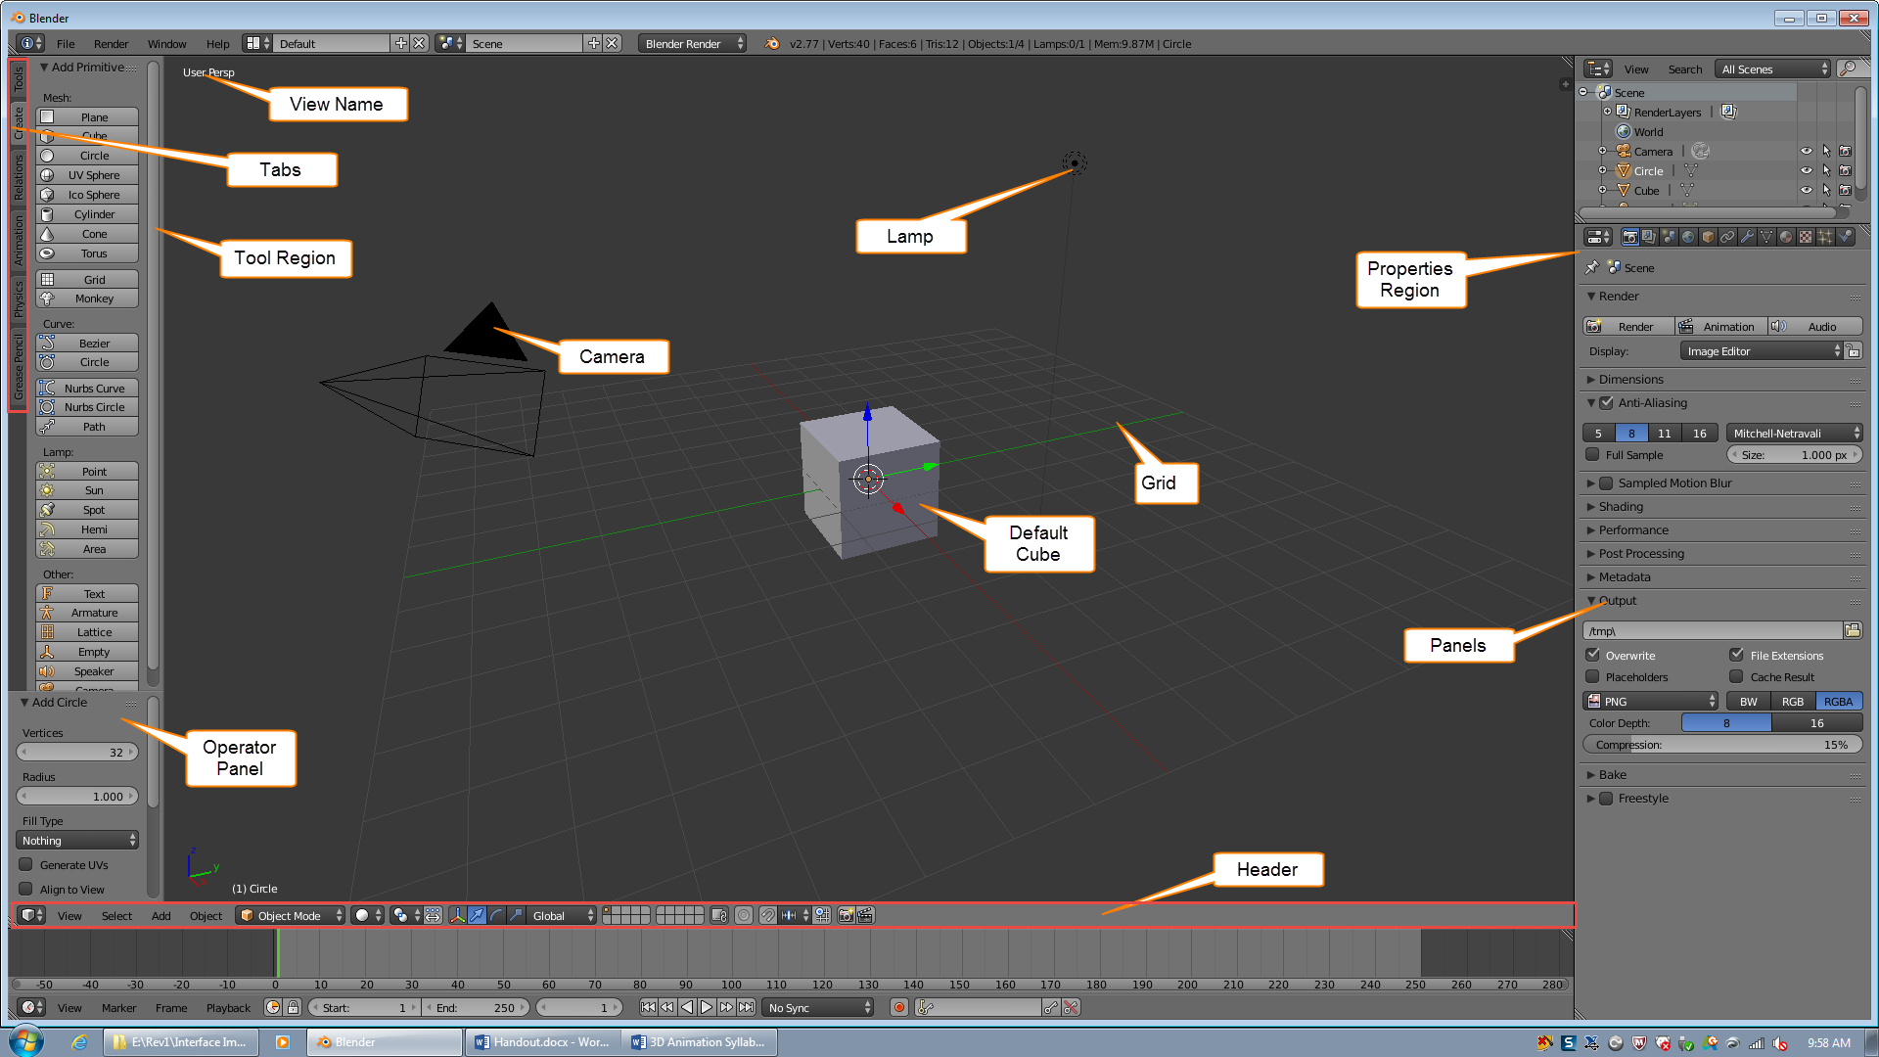

The 3D View

**View** **Name** – The view name is in the top left corner. Talk about different types of views.

Ortho (Orthographic) and Persp (Perspective).

**Tools** **Region** – Editors have regions to left or right of the view. Show or hide these tool regions by pressing **T** key. If tools region is hidden on the left border of the 3D View you will find a **+** button and click it.

**Tabs –** It Has tabs for different groups of tools.

**Operator Panel –** Show parameters of the select command.

**Camera –** The camera defines the point of view. It is an object that can also be manipulated.

**Default Cube –** A typical Blender file has a cube in the center.

**Lamp -**  All animations need a light source by default Blender give a Point lamp source. There are other types of light sources you will learn about later.

**Grid –** Represents the floor or ground in Blender measuring units. You will see X, Y and Z axis. Depending on the view.

**Units –** There is the ability to use realistic units. This course will use the Blender Units.

**Properties Region –** This region only contains property and parameters that interact with the 3D view contents.. It is hidden by default. Press **N** to open and close it.

**Panels –** Blender menus such as the Tools, Properties Regions or the Properties Editor are divided into panels. These panels show or hide there parameters by clicking on the small triangle to the left of the panel title.



List the Header Items from left to right

**Editor Selector, Collapse Menu Button, Editor’s Menu, Interaction Mode, Drawing Method selector, Pivot Selector, Transform Manipulators, Scene Layers, Global/Local layers Constraint button, Snapping selector, Preview Renders.**



List the Header Items from left to right

**Editor Selector, Render, Render Layers World, Scene, Object, Object Constraints, Modifiers, Mesh, Materials, Textures, Particles, Physics.**